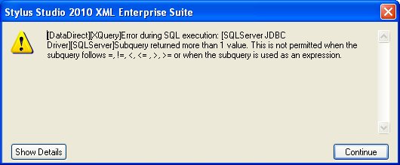

Selecting from database where Well ne “P&A”