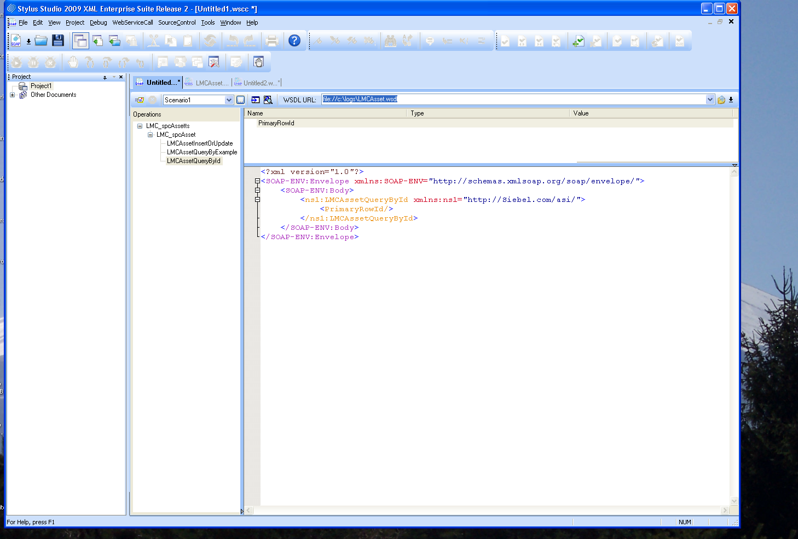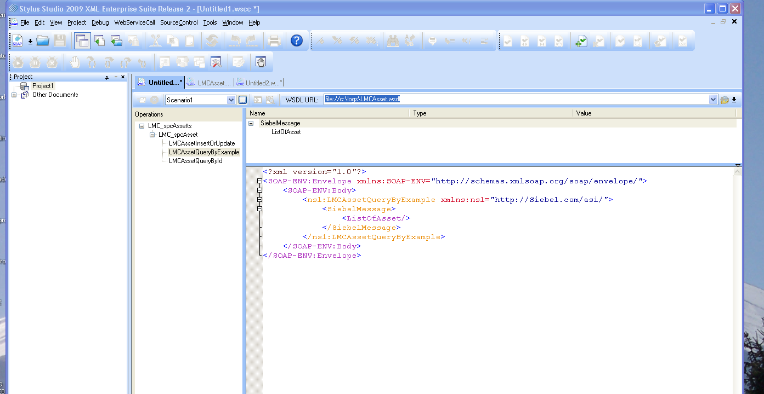

Copyright (C) 2001-2004 Siebel Systems, Inc. All rights reserved. Siebel XSD Generation

