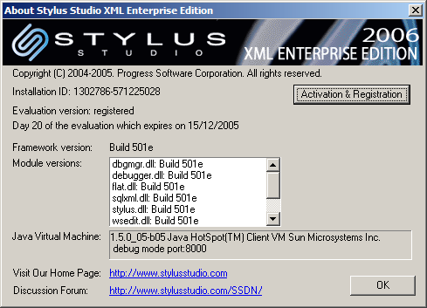

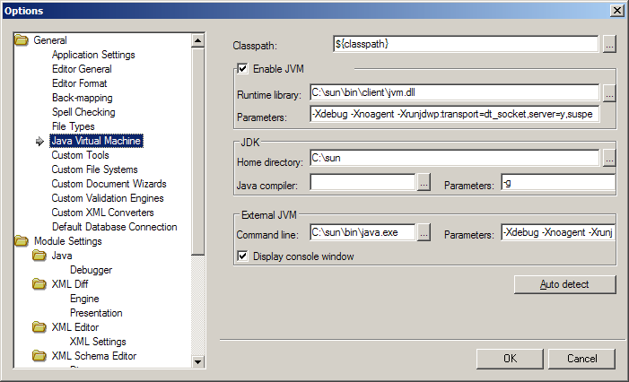

Compiler Classpath:"C:\Program Files\Altova\xmlspy\XMLSpyInterface.jar";
Compiling...
IntDate.java
Java compiler failed:
-g -classpath C:\PROGRA~1\Altova\xmlspy\XMLSPY~1.JAR "c:\StylusStudioEE\examples\javaExtension\IntDate.java"

