Ivan,
I believe I’m following the video, http://www.stylusstudio.com/videos/convert-to-xml3/convert-to-xml3.html, and when I Save As, below, which takes me to the “Select XML Converter” window.

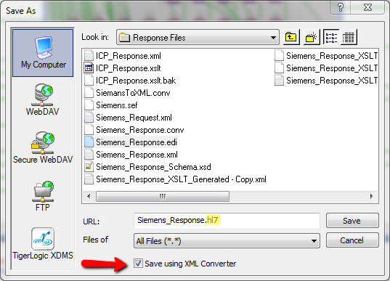
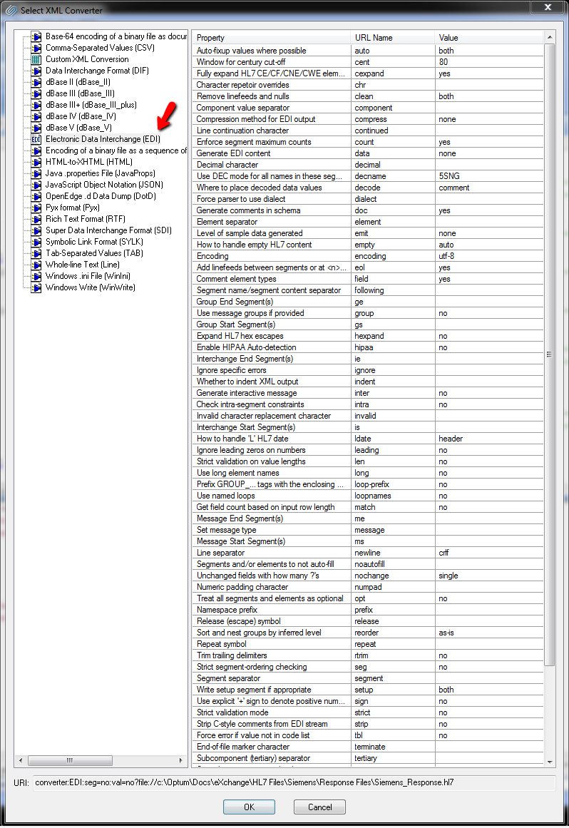
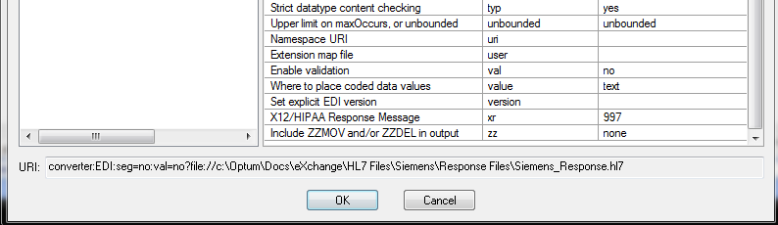
When I click the OK button I get the following error:

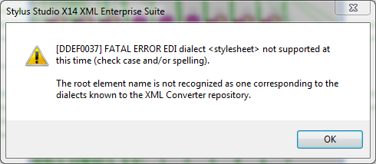

Are there some options I should be changing in order to create this HL7 message?

