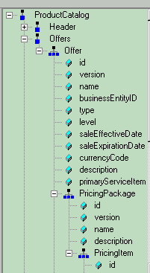

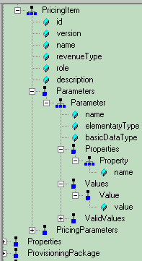

1. Output lists Offer Name:

<xsl:for-each select="ProductCatalog/Offers/Offer">
<tr vAlign="top">
<td vAlign="top" width="215" style="border-bottom-width: thin; border-bottom-color: #000000">
<strong>
<xsl:value-of select="@name"/>
</strong>
</td>

2. For each Offer Name, output lists multiple PricingPackages names:

<xsl:for-each select="PricingPackage">
<td vAlign="top">
<xsl:value-of select="@name"/>
</td>
</xsl:for-each>

2. For each Offer Name, output lists for each PricingPackage/PricingItem multiple parameters and their value but without keeping the relation of parent PricingPackage name:

<xsl:for-each select="PricingItem/PricingParameters/Parameter[name = 'Chrage code']">,
</td>
<xsl:value-of select="@name"/>,
<xsl:value-of select="Values/Value/@value"/>

</td>
</xsl:for-each>

Required: Output to list for each Offer Name multiple PricingPackages names AND for each PricingPackage/PricingItem multiple Parameters names and their value in separate output table rows:

Pricing Package name
Offer name Pricing Package name PricingPackage/PricingItem/Parameter name & value
Pricing Package name Parameter name & value
Parameter name & value

See table format:

Current: doesn't keep the Parameter relation to the parent PricingPackage, just lists in one row
Offer name | Pricing Packages |  | Parameter Name and Value
A | Package 1 | Package 2 | Param 1.1 | Param 1.2 | Param 2
B | Package 1 | Package 2 | Param 1 | Param 2
C | Package 1 |  | Param 1.1 | Param 1.2 | Param 1.3
Required:
Offer name | Pricing Packages | Parameter Name and Value
A | Package 1 | Param 1.1
 |  | Param 1.2
 | Package 2 | Param 2
B | Package 1 | Param 1
 | Package 2 | Param 2
C | Package 1 | Param 1.1
 |  | Param 1.2
 |  | Param 1.3

