**Stylus Studio X16 XML Professional Suite**

I am not able to set JVM for stylus studio. Please see screen-shot below:

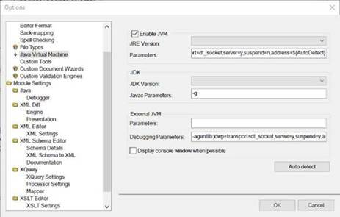

This should be something as below:

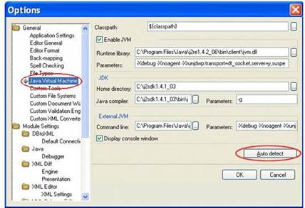

Do I need to enable some setting?