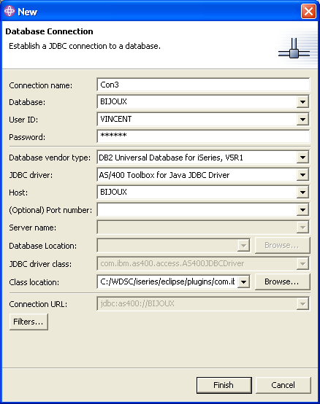
C:/WDSC/iseries/eclipse/plugins/com.ibm.etools.iseries.toolbox_5.1.2.4/runtime/jt400.jar

