Here is a screen shot after I mapped two elements from the source document. Though I am not showing it, the transformation ran correctly and created the expected output.

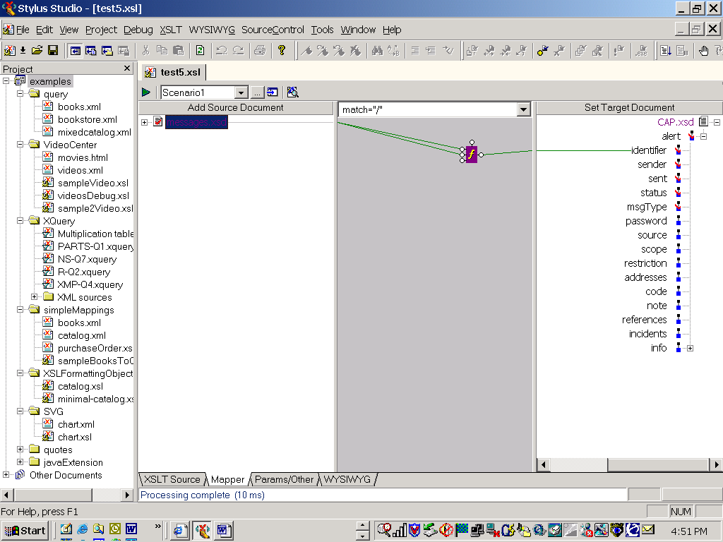

Here is a screen shot after I add a text block to the concate.

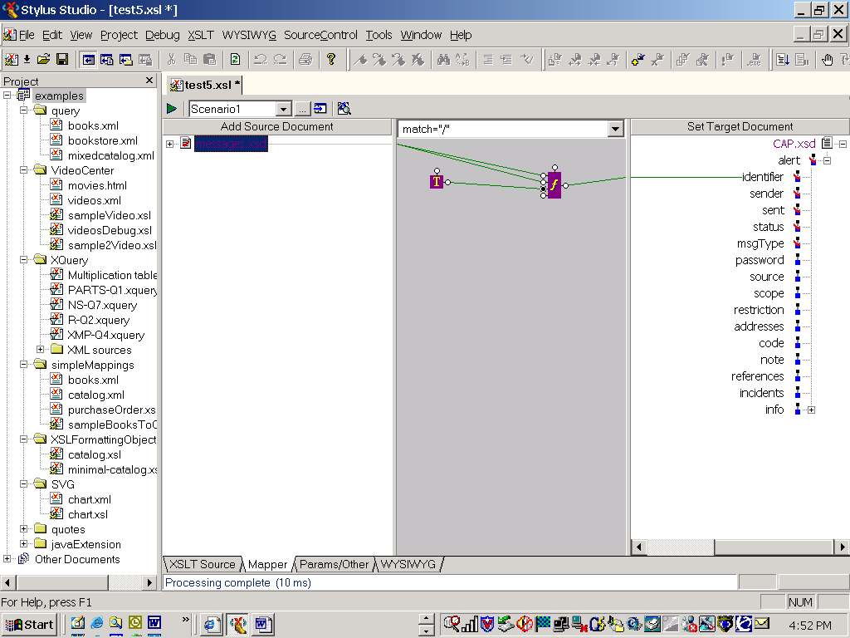

After the above screen shot, all I did was save the map. After I did the save, the icon in the grey mapping section changed as you see below.

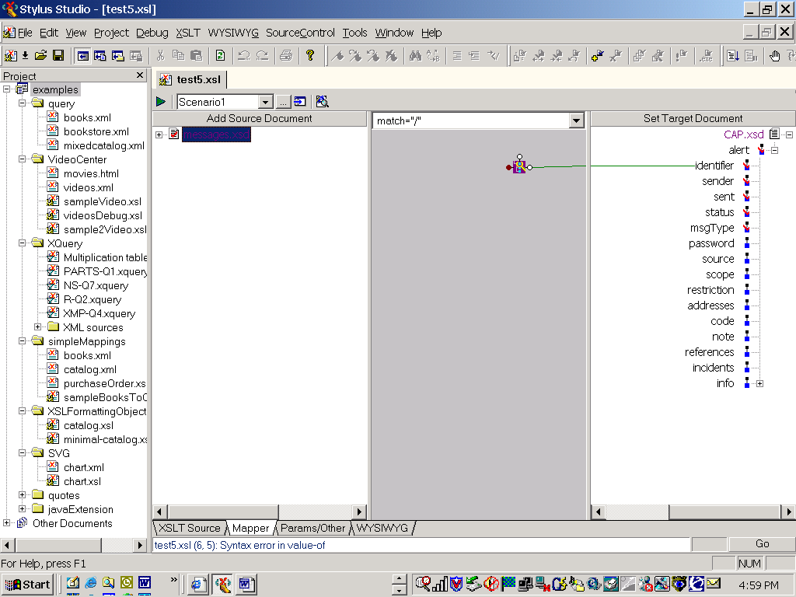

And when I try to generate the output XML this error message appears.

