I registered the TextTruncator function as bellow:
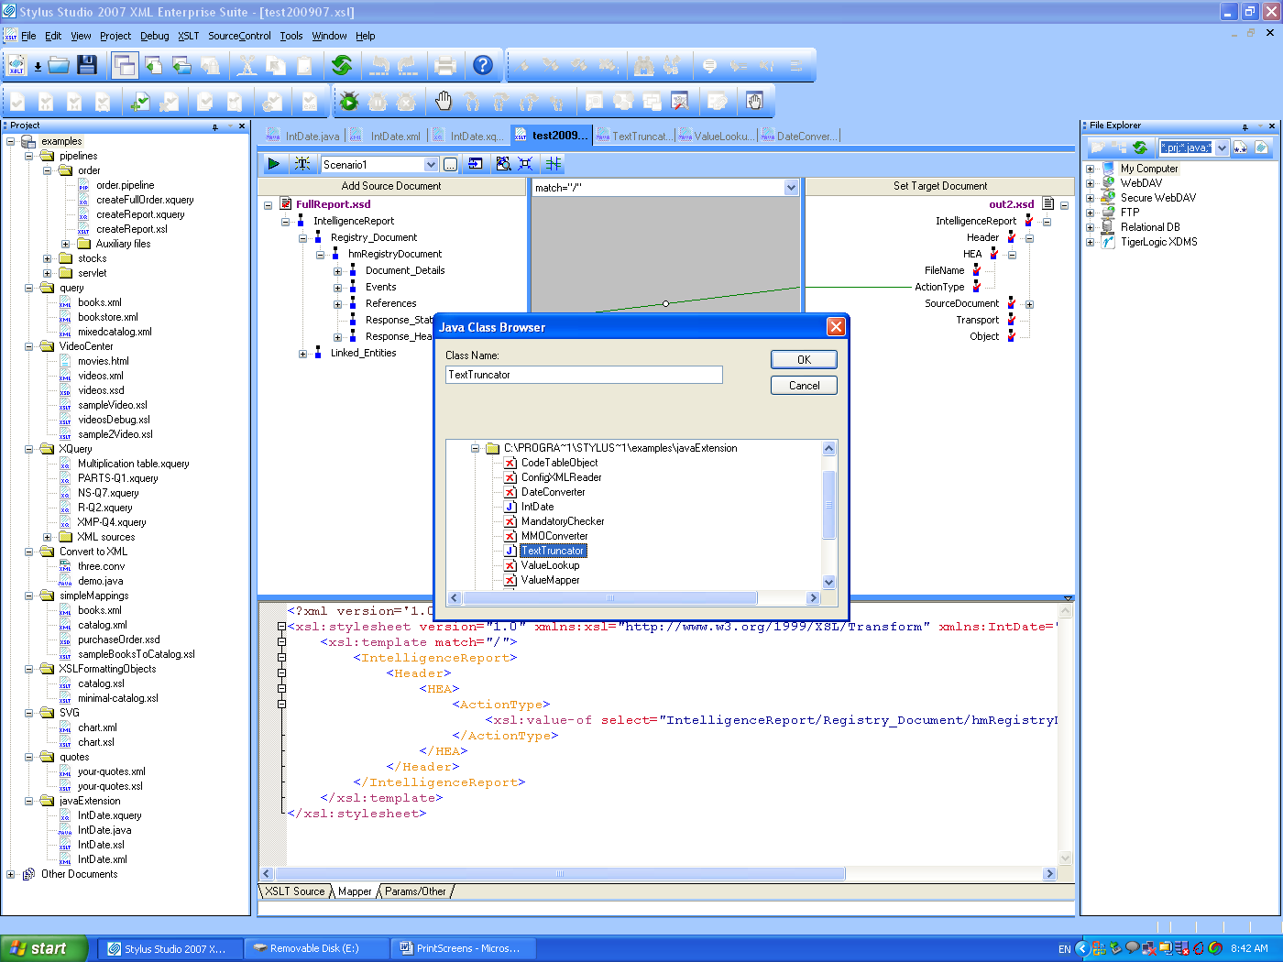

I should now be able to use the TextTruncator function, but it did not appear in the list for me to use:
