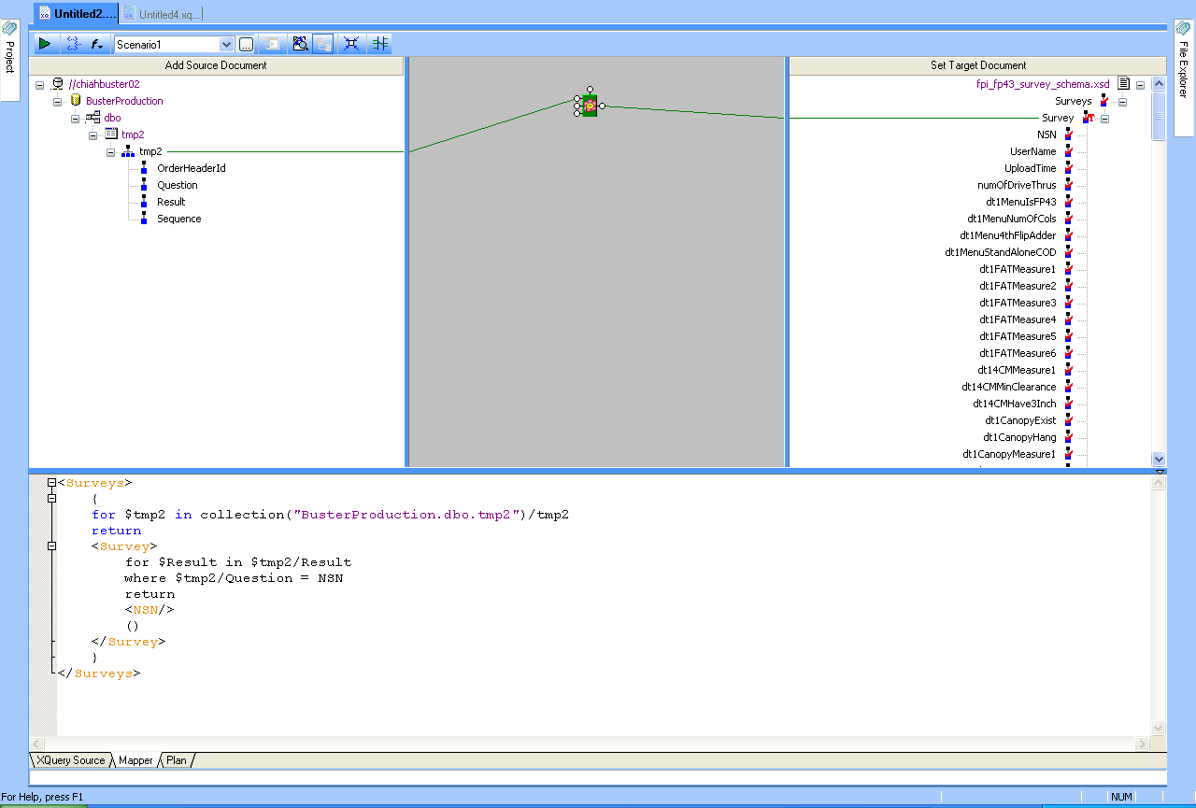

I am trying to create a XML file for the survey results. The table on the left has results of the survey. “Question” field has values same as the XML nodes on the right(eg. NSN, numOfDriveThrus). What I want to do is check value of Question on the left and if it equals “NSN” then assign value from “Result” field to the NSN element in the xml file. The XML file on the right is from a schema from our customer.

Thanks in advance.

